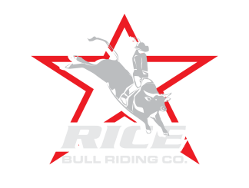
USINES NAE: __________________________________________________
CONTACT NAME: _____________________________PHONE: ____________
CONTACT EMAIL: _________________________________________________

ADDRESS: ________________________________________________________
CITY: ______________________________STATE: _______ZIP: ____________

Please attach a business card or your completed ad for program book.

**SPONSORSHIP/ADVERTISING OPTIONS:

Event Sponsorship
_____ Event sponsor - $2500.00 ___ Kids sponsor - $500
_____ Bull Riding Trophy sponsor - $1000 ___ Chute Sponsor - $500
_____ Barrel Racing Trophy sponsor - $1000
_____ Clown sponsor -$500 ___ Bullfighter sponsor-$500

Advertisement (supplied by you and returned)
____ Banner sponsors - $250 ___ Display booth - $150
Banners you need provided by us: Quantity______ X $60 = Total_________

**DEADLINE: Most of these packages are only available to one business so timing is of the essence to reserve your sponsorship package. We need print ready artwork for the Event Program book and banners if we are supplying by June 15th if you have any questions, please call Christina Rice at 763-389-1399 or email christina@ricebullridingcompany.com or dave@ricebullridingcompany.com
Please return form with check to. Rice Bull Riding Company
We also accept credit cards (phone only)
13037 314th Ave NW
Princeton, MN 55371

Artwork/Logos email to
dave@ricebullridingcompany.com

